**Aim: Implementation of dimensionality reduction techniques:**

**Normalization, Transformation, Principal Components Analysis.**

# NORMALIZATION:-

Normalization is a technique often applied as part of data preparation for machine learning. The goal of normalization is to change the values of numeric columns in the dataset to use a common scale, without distorting differences in the ranges of values or losing information. Normalization is also required for some algorithms to model the data correctly.

For example, assume your input dataset contains one column with values ranging from 0 to 1, and another column with values ranging from 10,000 to 100,000. The great difference in the scale of the numbers could cause problems when you attempt to combine the values as features during modeling.

Normalization avoids these problems by creating new values that maintain the general distribution and ratios in the source data, while keeping values within a scale applied across all numeric columns used in the model.

# SOURCE CODE:

1. **Importing Datasets:**

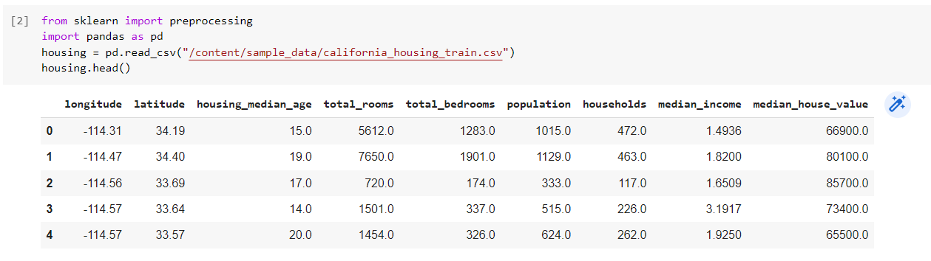

1. **Normalizing- MinMaxScalar Transformation of Dataset:**

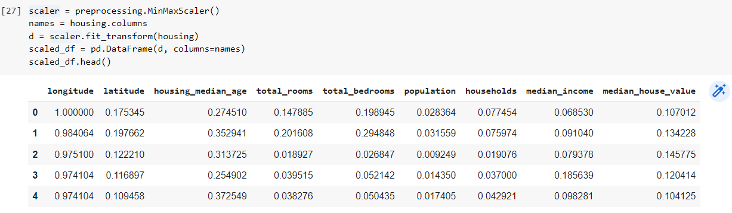

# Principal Component Analysis:-

Principal Component Analysis (PCA) is a statistical procedure that uses an orthogonal transformation that converts a set of correlated variables to a set of uncorrelated variables. PCA is the most widely used tool in exploratory data analysis and in machine learning for predictive models. Moreover, PCA is an unsupervised statistical technique used to examine the interrelations among a set of variables. It is also known as a general factor analysis where regression determines a line of best fit.

**SOURCE CODE:**

1. **Importing Dataset:**

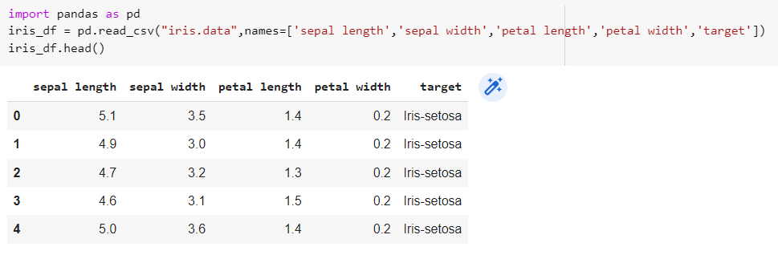

1. **Standardize the Data:**

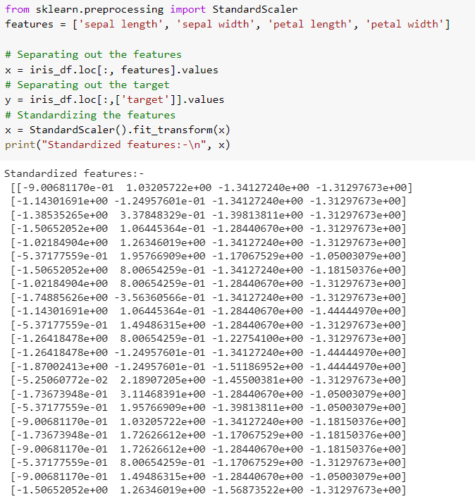

1. **PCA Projection to 2D:**

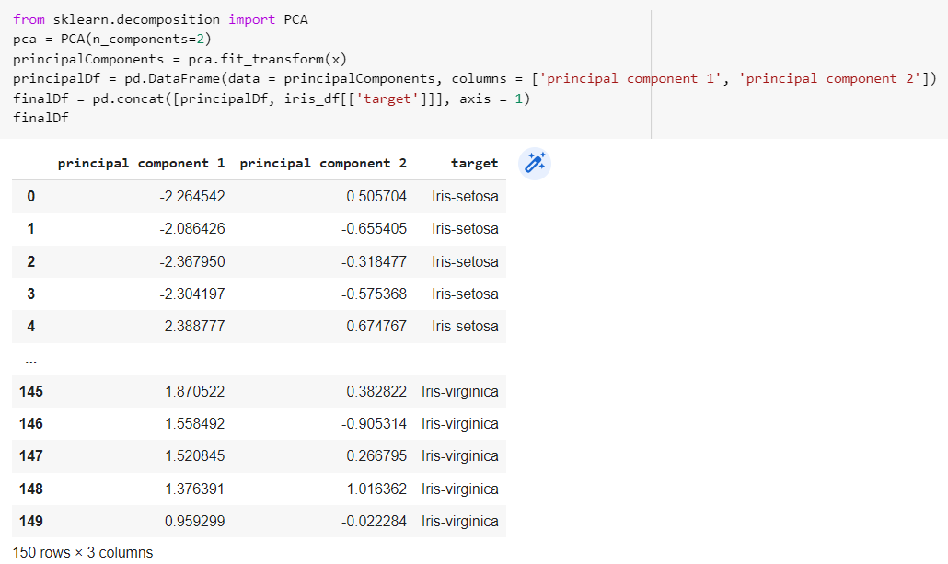

1. **Visualize 2D Projection:**

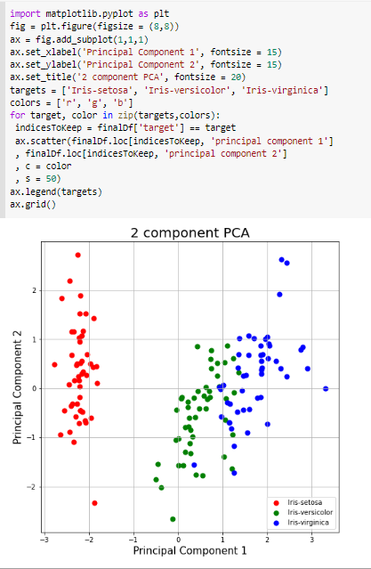

**CONCLUSION:**

From this practical, I have learned and implemented dimensionality reduction techniques: Normalization, Transformation, Principal Components Analysis.